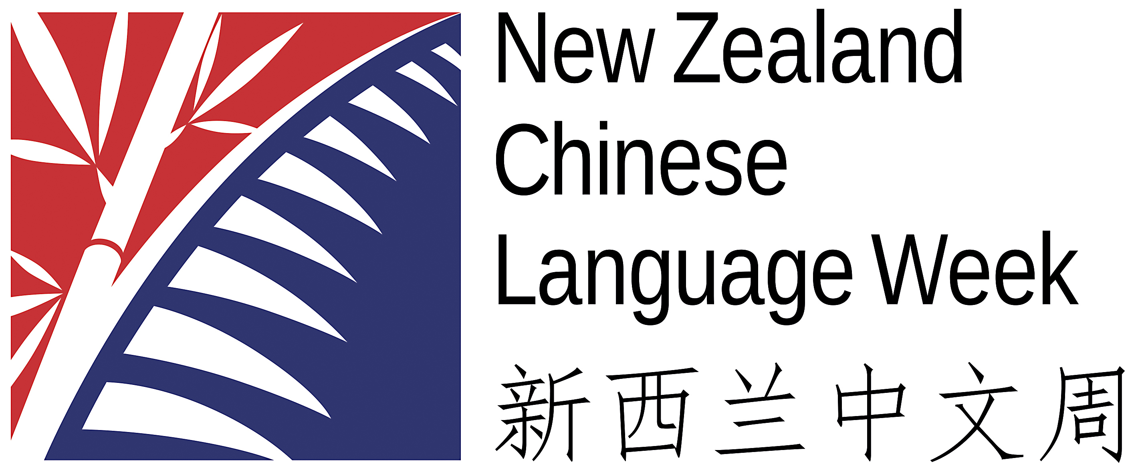
New Zealand Chinese Language Week Event Form
NZCLW would love to be able to promote your event on our website, social media and through the media. Please fill out this form to let us know some brief detail about the event.

Name of the Event
Location/address of event
Date and Time
Event organizer/contact for NZCLW internally
Contact info for the public
Is this event open to the public or not?
Are you happy to be contacted about media interest?
Small description of the event and any other info

If you would like, please attach an image to be used for the event promo. This is optional as we can use one of our images. Please email this form to nzclw@nzclw.com

